HOW TO REACH THE FLINS 2006 CONFERENCE HOTEL

FLINS 2006 will be held in Genova, Italy, at the STARHOTEL PRESIDENT. The address is:

STARHOTEL PRESIDENT
C.TE LAMBRUSCHINI, 4
16129 GENOVA
tel. +39.0105727
http://www.starhotels.com/default.asp?prj=main&sec=star&menuid=22

The conference hotel is about 50 meter from the Brignole Station, one of the two main train stations in Genova. Genova is directly connected by train to Milano (120 km), Torino (200 km), Roma (500 km), Nice (200 km). For train timetable and fares:
http://www.trenitalia.it/en/index.html (in english)

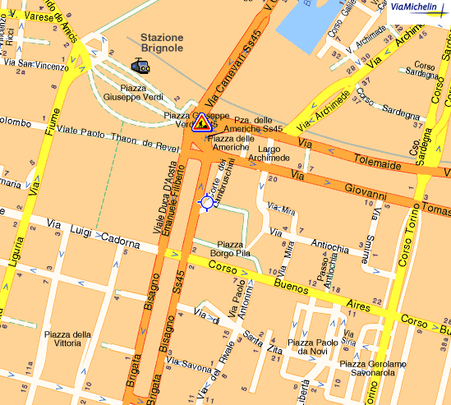

Arriving at GENOVA airport (Critoforo Colombo Airport):

The conference hotel, downtown Genova, is about 20 minutes by taxi or bus from the airport. The taxi fare is about 25 EUR, or you can take the bus (Volabus 100), right outside the airport terminal. Volabus 100 will take you at the Brignole train station, which is 50m from the conference hotel. The ticket price is 4.00 EUR.

Arriving at Milano Malpensa airport:

You will be arriving at Terminal 1. Take the shuttle to Milano Central Station, right outside the arrival terminal, MALPENSA Shuttle, every 20 minutes, fare 5.00 EUR (50 minutes drive). For further information see http://www.malpensashuttle.it/
PLEASE NOTE: There is also a MALPENSA express train, but it will NOT take you at the Central Station, so do not take it. Do not take the train from the airport, or you will get lost in Milano.

From Milano Central Station, take the train to Genova Brignole (about 1.5 hours trip). Find the timetable at:
http://www.trenitalia.it/en/index.html (in english)

You can rent a car both in Milano Malpensa or Genova airport. If you drive from Milano Malpensa, follow the path in the following map (about 2 hours drive):

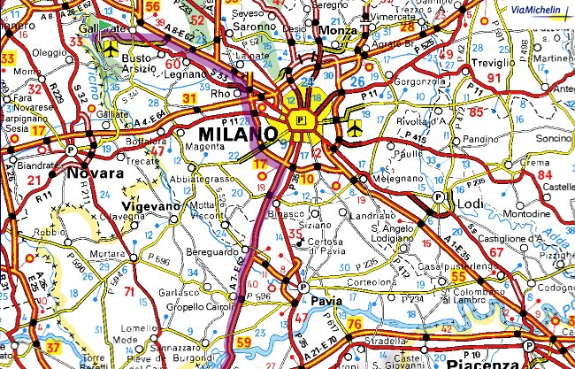

Higway A7 will take you to Genova, exit Genova Est. From there, follow the indications to Genova Brignole train station.

If you rent a car at the Genova airport, follow the route in this map:

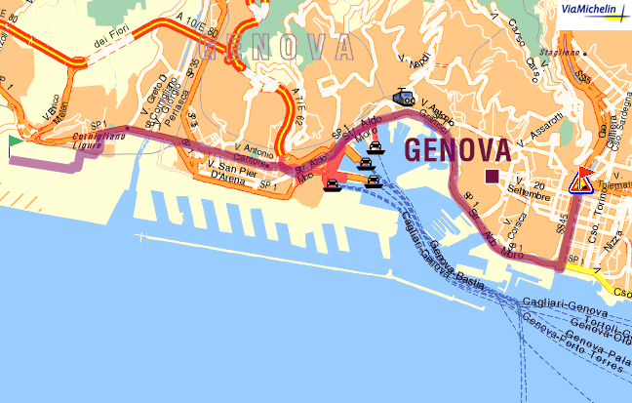

To have a detailed route information, please consult:
http://www.viamichelin.co.uk/viamichelin/gbr/dyn/controller/Driving_directions
(in english)
Put in the departure address field “airport” and in the city field “milano” or “genova”, whatever applicable. In the destination address, use “corte lambruschini” and in the destination city “genova”.

